**Lab No 14**

**Name : Muhammad Faizan Reg. No. : 21-NTU-CS-1258**

**(Q1)**

#include<iostream>

#include<cstring>

#include<fstream>

using namespace std;

int main(){

ifstream file("data.txt");

if(!file){

cout<<"Can't Open ";

}

char i;

while(file>>i){

cout<<i<<endl;

}

ifstream file1("data.txt");

if(!file1){

cout<<"Can't Open ";

}

string word;

while(file1>>word){

cout<<word<<endl;

}

ifstream file2("data.txt");

if(!file1){

cout<<"Can't Open ";

}

string sen;

while(getline(file2, sen)){

cout<<sen<<endl;

}

}

**Output**

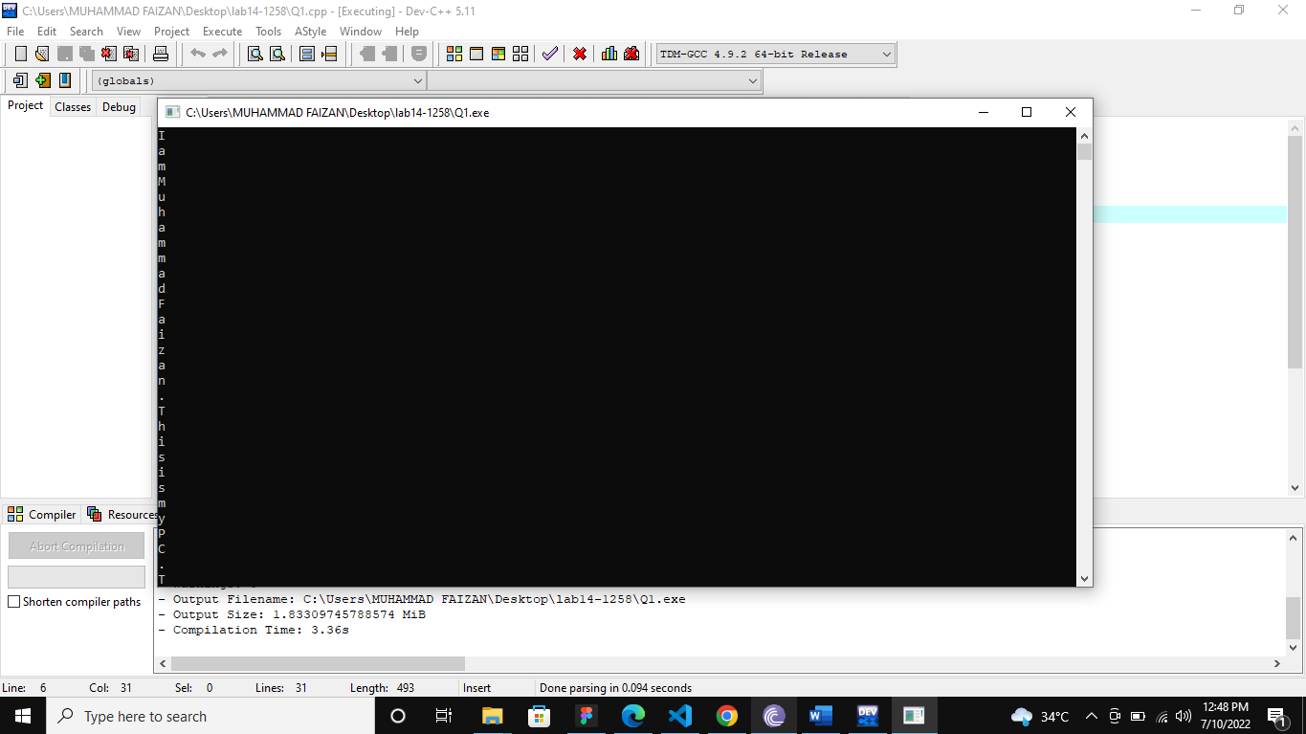

**(Q2)**

#include<iostream>

#include<cstring>

#include<fstream>

using namespace std;

int main(){

ofstream file("new.txt");

if(!file){

cout<<"Error ";

}

file<<"I am Muhammad Faizan "<<endl;

file<<"This is my PC "<<endl;

file<<"This is programming class "<<endl;

file<<"Compiler is Dev "<<endl;

file<<"Software is microsoft teams "<<endl;

ifstream file1("new.txt");

if(!file1){

cout<<"Error ";

}

string a;

while(file1>>a){

cout<<a<<" ";

}

}

**Output**

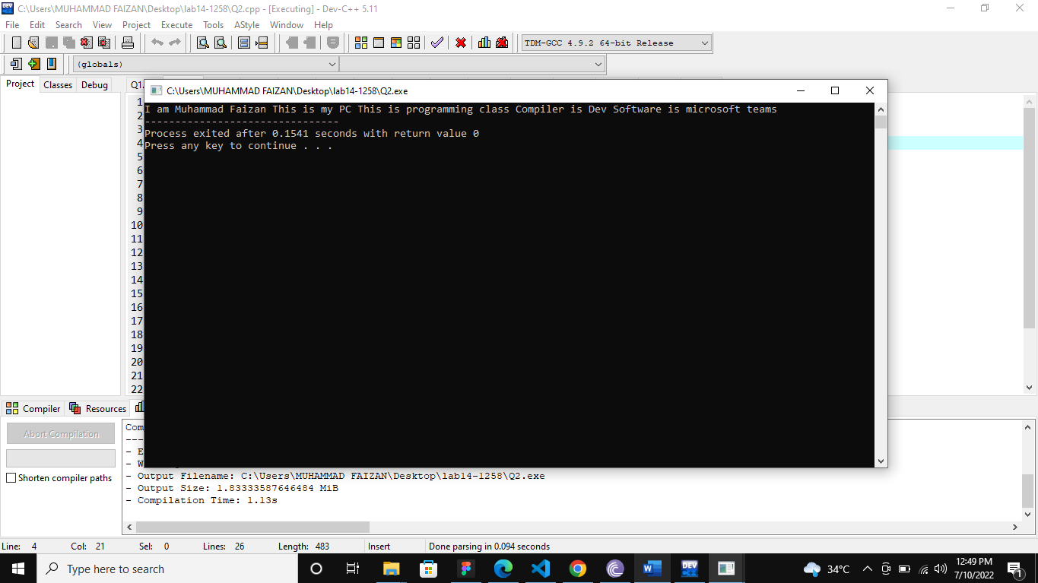

**(Q3)**

#include<iostream>

#include<cstring>

#include<fstream>

using namespace std;

int main(){

ofstream file("ndata.txt");

if(!file){

cout<<"Can't Open ";

}

char array[200]="I am Muhammad Faizan. This is my PC. This is programming class. Compiler is Dev. Software is microsoft teams.";

file<<array;

file.close();

ifstream open("ndata.txt");

if(!open){

cout<<"Error";

}

string word;

while(getline(open, word)){

cout<<word<<endl;

}

}

**Output**

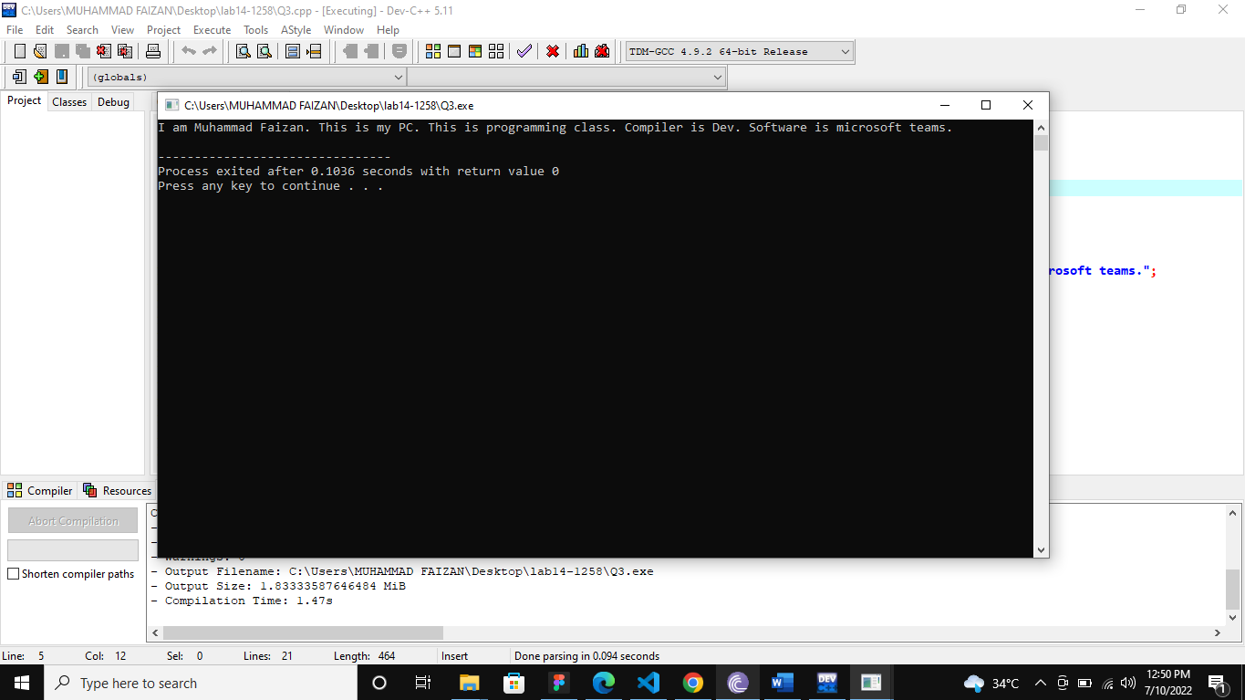

**(Q4)**

#include<iostream>

#include<cstring>

#include<fstream>

using namespace std;

int main(){

ofstream file("writer");

if(!file){

cout<<"Can't Open";

}

file<<"You will find it very good\ngood practice always to verify\nyour references\n (Dr. Routh)";

file.close();

ifstream file1("writer.txt");

if(!file1){

cout<<"Error";

}

string a;

while(getline(file1, a)){

cout<<a<<endl;

}

}

**Output**

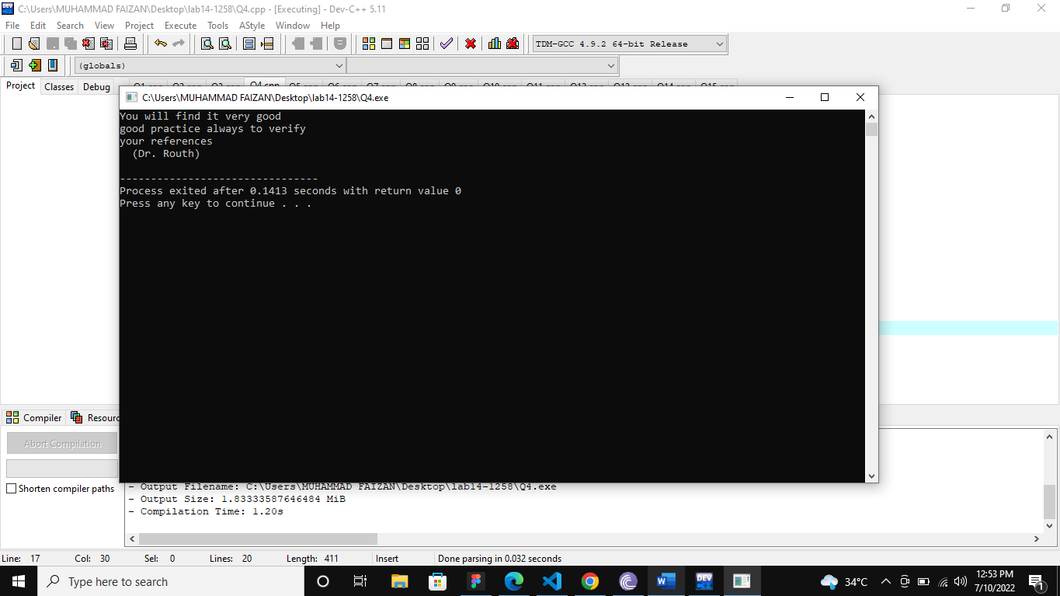

**(Q5)**

#include<iostream>

#include<cstring>

#include<fstream>

using namespace std;

int main()

{

ifstream fh("writer.txt");

if(!fh)

{

cout<<"Can't Open"<<endl;

}

string a;

while(getline(fh, a))

{

cout<<a<<" ";

}

}

**Output**

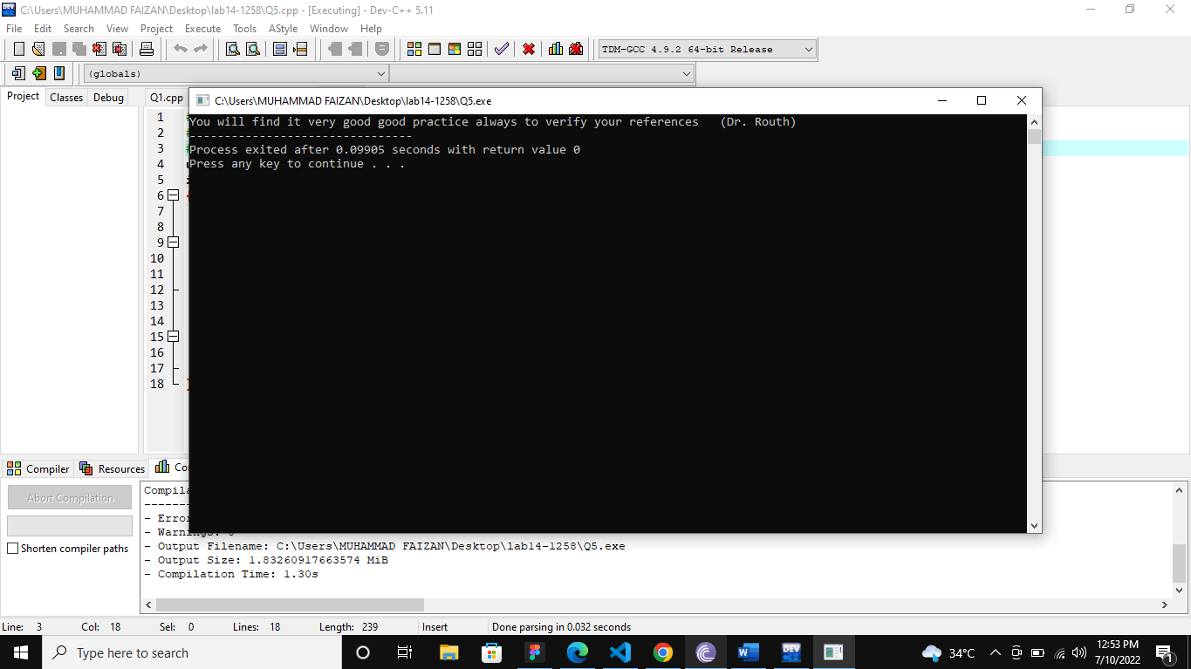

**(Q6)**

#include<iostream>

#include<cstring>

#include<fstream>

using namespace std;

int main()

{

ofstream file("Q6.txt");

if(!file)

{

cout<<"Error";

}

string abc;

cout<<"Enter a sentence ";

getline(cin,abc);

file<<abc;

file.close();

ifstream open("Q6.txt");

if(!open)

{

cout<<"Error";

}

string sen;

while(getline(open,sen))

{

cout<<sen<<endl;

}

}

**Output**

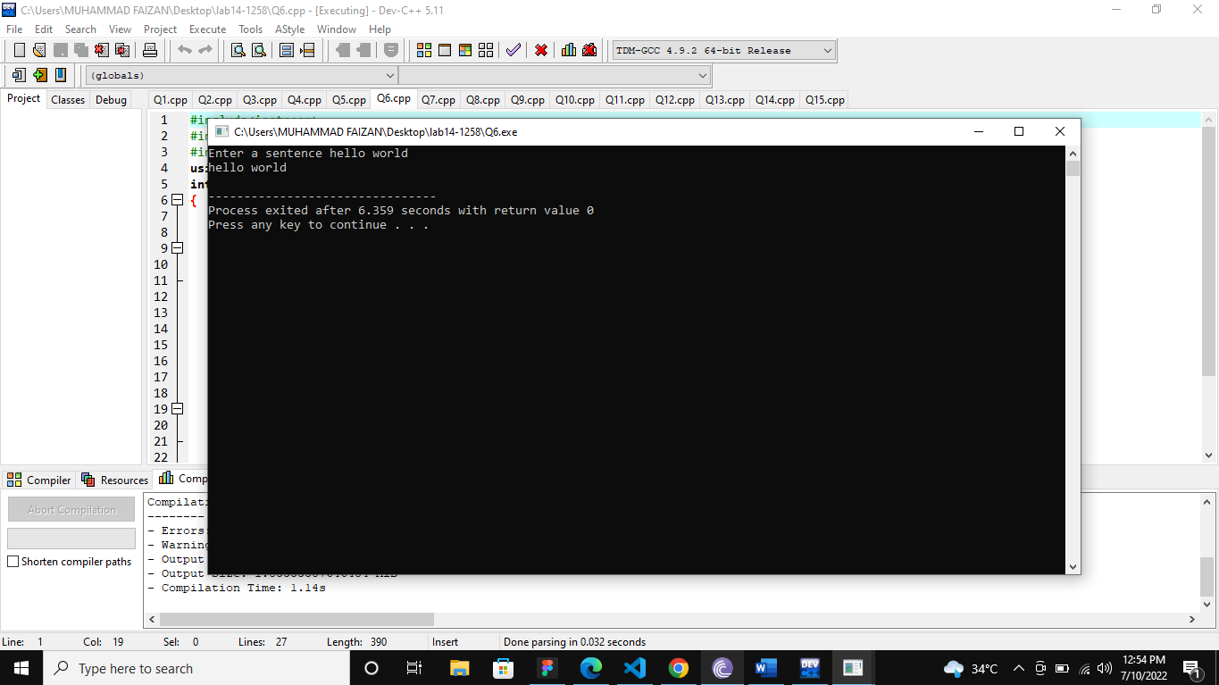

**(Q7)**

#include<iostream>

#include<cstring>

#include<fstream>

using namespace std;

int main()

{

ifstream file("sample.txt");

if(!file)

{

cout<<"File can't open ";

}

string word;

int count=0;

while(file>>word)

{

count++;

}

cout<<"Total number of words : "<<count;

}

**Output**

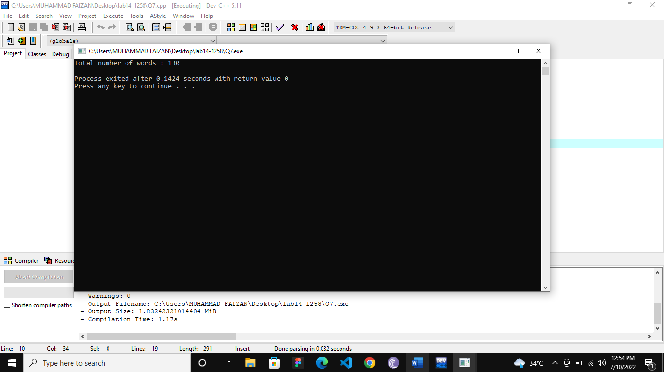

**(Q8)**

#include<iostream>

#include<fstream>

using namespace std;

int main()

{

ifstream fh("Sample.txt");

if(!fh)

{

cout<<"File could not be opened."<<endl;

}

string c, a;

cout<<"Enter the word : ";

cin>>c;

int b=0;

while(fh>>a)

{

if(c==a)

{

b++;

}

}

if(b==0)

cout<<"\nThe word "<<c<<" exists in the \"Sample.txt\""<<endl;

else

cout<<"\nThe word "<<c<<" does not exists in the \"Sample.txt\""<<endl;

}

**Output**

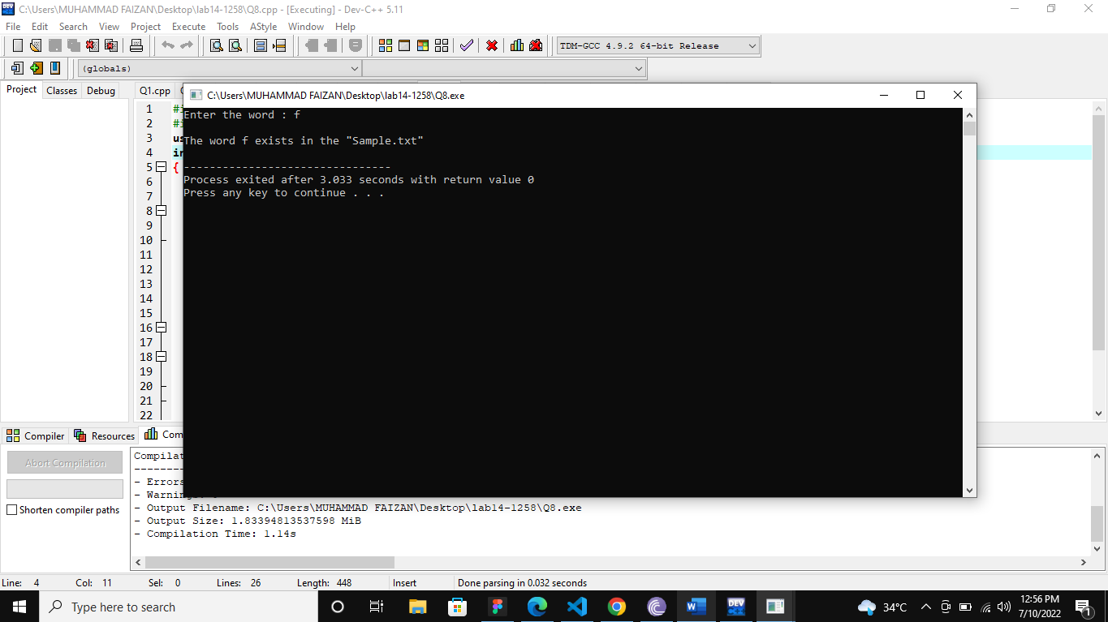

**(Q9)**

#include<iostream>

#include<fstream>

#include<cstring>

#include<stdio.h>

using namespace std;

int main()

{

ifstream fh("Sample.txt");

char line[200][10];

if(!fh)

{

cout<<"File could not be opened."<<endl;

}

char r[50], c[50], g[50];

int a, d;

do

{

cout<<"Enter the word you want to Replace : ";

cin>>c;

cout<<"\nEnter the word you want to Replace with for same size with \""<<c<<"\" : ";

cin>>r;

}while(strlen(c)!=strlen(r));

int b=0, x=0;

cout<<"\n\n===================================Before Swaping the word=========================\n\n";

while(fh>>g)

{

if(strcmp(c,g)==0)

{

b++;

}

x++;

cout<<g<<" ";

}

fh.close();

if(b==0)

cout<<"\n\nThe word \""<<c<<"\" exists in the \"Sample.txt\""<<endl;

else

cout<<"\n\nThe word \""<<c<<"\" does not exists in the \"Sample.txt\""<<endl;

ifstream fileh("Sample.txt");

if(!fileh)

{

cout<<"File could not be opened."<<endl;

}

cout<<"\n\n===================================After Swaping the word=========================\n\n";

while(!fileh.eof())

{

for(int i=0; i<x; i++)

{

fileh>>line[i];

}

}

fileh.close();

for(int i=0; i<x; i++)

{

if(strcmp(line[i], c)==0)

{

strcpy(line[i], r);

}

cout<<line[i]<<" ";

}

ofstream hfil("Sample.txt");

if(!hfil)

{

cout<<"File could not be opened."<<endl;

}

for(int i=0; i<x; i++)

{

hfil<<line[i]<<" ";

}

cout<<endl<<endl;

}

**Output**

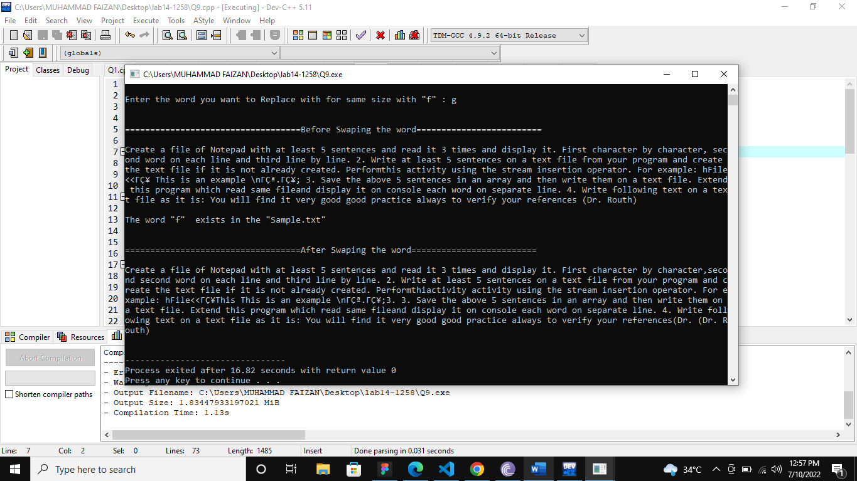

**(Q10)**

#include<iostream>

#include<fstream>

using namespace std;

int main()

{

ifstream fhandle("Q10.txt");

ofstream fh("Q10p1.txt");

if(!fhandle)

{

cout<<"File could not be opened."<<endl;

}

if(!fh)

{

cout<<"File could not be opened."<<endl;

}

string a;

while(getline(fhandle, a))

{

fh<<a;

}

return 0;

}

**Output**

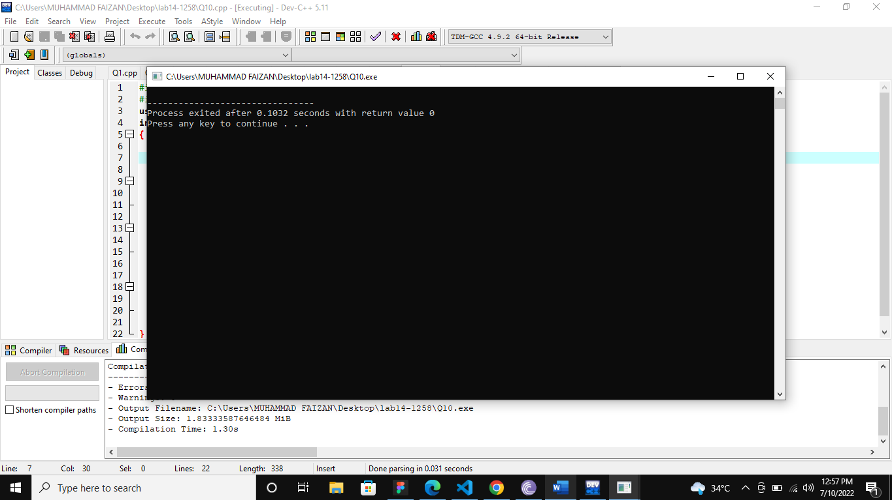

**(Q11)**

#include<iostream>

#include<fstream>

using namespace std;

int main()

{

ifstream fhandle("Q10.txt");

ofstream fh("Q10p1.txt", ios::app);

if(!fhandle)

{

cout<<"File could not be opened."<<endl;

}

if(!fh)

{

cout<<"File could not be opened."<<endl;

}

string a;

while(getline(fhandle, a))

{

fh<<a;

}

return 0;

}

**Output**

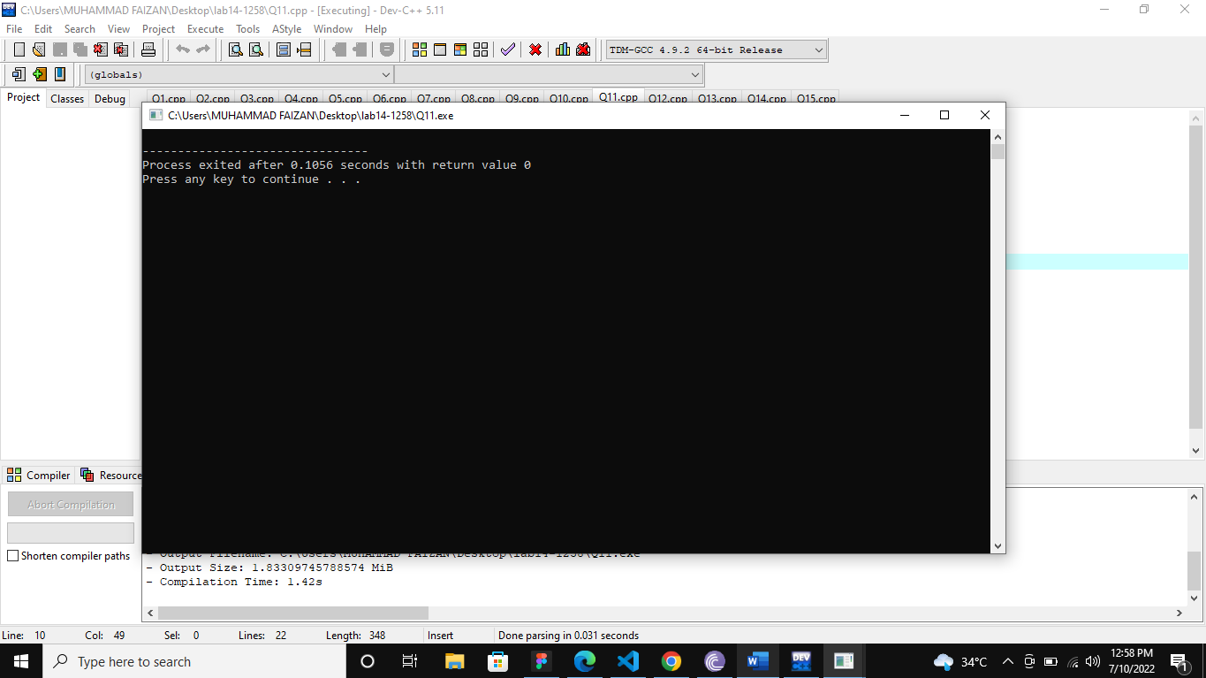

**(Q12)**

#include<iostream>

#include<fstream>

using namespace std;

int main()

{

ifstream fhandle("Sample.txt");

if(!fhandle)

{

cout<<"File could not be opened."<<endl;

}

char a;

int b;

fhandle.seekg(0L, ios::end);

b=fhandle.tellg();

cout<<"Total Number of characters : "<<b<<endl;

}

**Output**

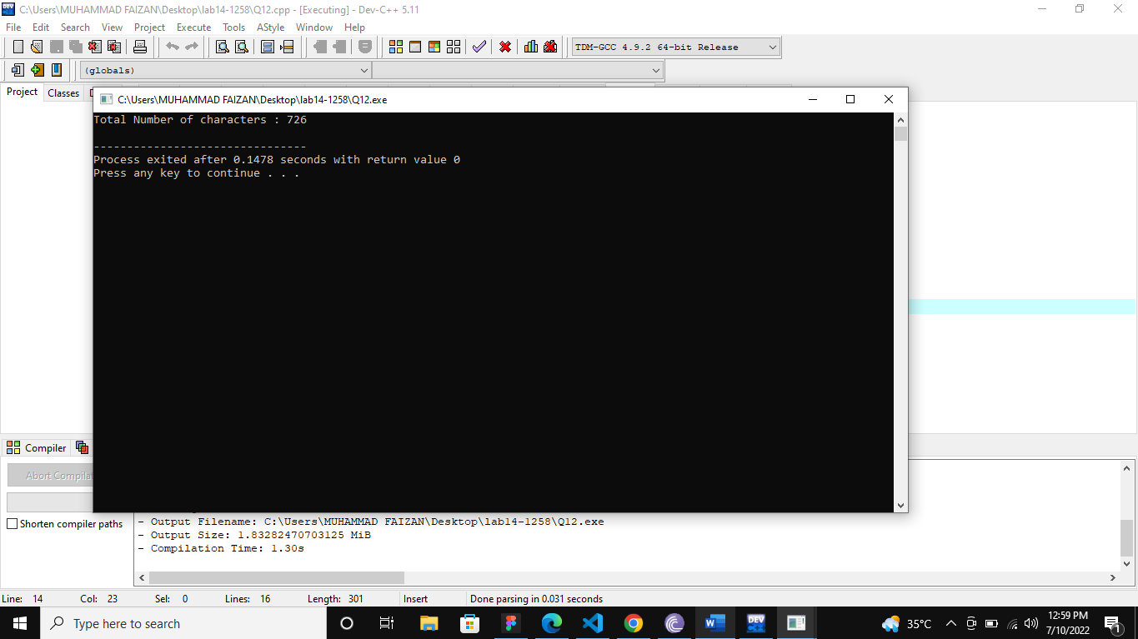

**(Q13)**

#include<iostream>

#include<fstream>

using namespace std;

int main()

{

ifstream fhandle("Sample.txt");

if(!fhandle)

{

cout<<"File could not be opened."<<endl;

}

fhandle.seekg(0L, ios::end);

int a, b;

char c;

a = fhandle.tellg();

b = a/2;

fhandle.seekg(b);

while(fhandle>>c)

{

cout<<c<<"\t\t"<<fhandle.tellg()<<endl;

}

}

**Output**

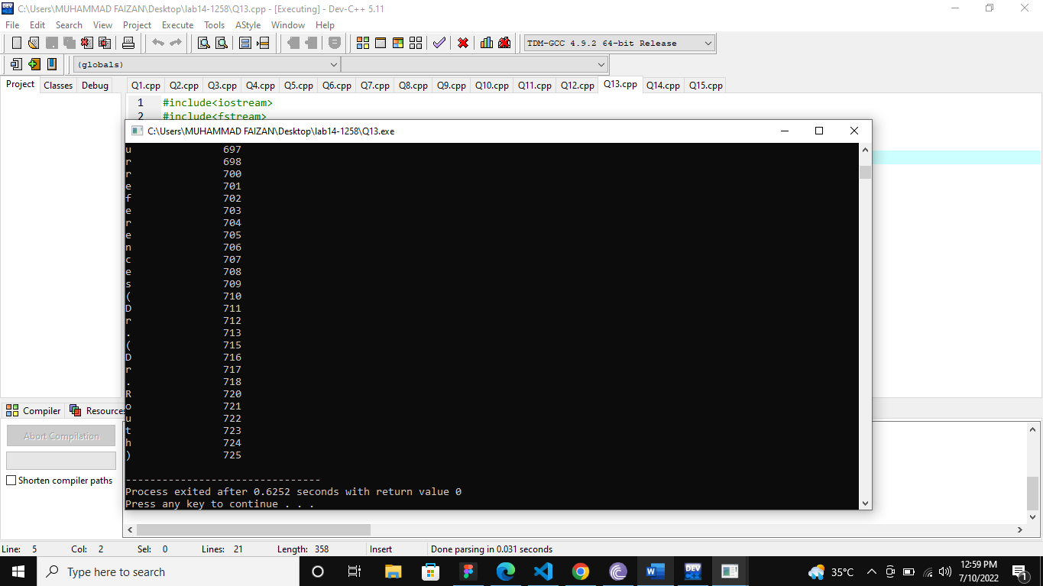

**(Q14)**

#include <fstream>

#include <iostream>

using namespace std;

int main()

{

ifstream in("Q14.txt");

string line[60], c;

int g=0;

while(in>>c)

{

g++;

}

in.close();

ifstream fh("Q14.txt");

while(!fh.eof())

{

for(int i=0; i<g; i++)

{

fh>>line[i];

}

}

cout<<"\n\n====================================CORRECT ORDER=====================================\n\n"<<endl;

for(int i=0; i<g; i++)

{

cout<<line[i]<<endl;

}

cout<<"\n\n====================================REVERSE ORDER======================================\n\n"<<endl;

for(int i=g; i>=0; i--)

{

cout<<line[i]<<endl;

}

}

**Output**

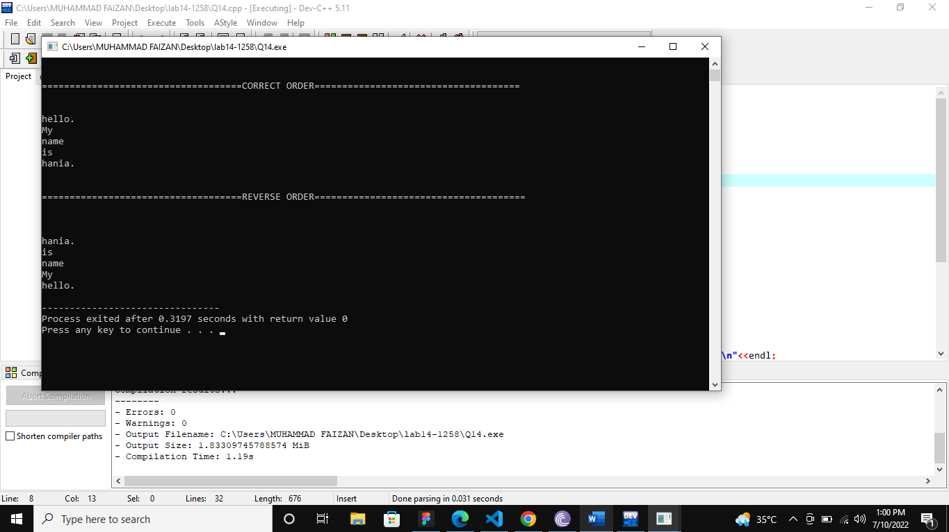

**(Q15)**

#include<iostream>

#include<fstream>

#include<conio.h>

#include<iomanip>

#include<cstring>

using namespace std;

class Telephone{

struct data{

char First_Name[30];

char Last_Name[30];

long long Phone_Number;

char Email[30];

char City[30];

};

public:

void input();

void display();

void search_with_First_Name();

void search_with_City();

void Update_First_Name();

void Update_Phone_Number();

int Menu();

};

int Telephone::Menu(){

int menu;

system("cls");

cout<<"\t\t\t Telephone Directory\n\n";

cout<<"\t1--------------------->Input\n";

cout<<"\t2--------------------->Display All\n";

cout<<"\t3--------------------->Search with First Name\n";

cout<<"\t4--------------------->Search with City\n";

cout<<"\t5--------------------->Update First Name\n";

cout<<"\t6--------------------->Update Phone Number\n";

cout<<"\t7--------------------->Exit\n\n\n";

cout<<"Enter Choice : ";

cin>>menu;

cout<<endl<<endl;

return menu;

}

void Telephone::input(){

data s;

fstream fh("Record.txt", ios::app | ios::binary);

system("cls");

if(!fh){

cout<<"File could not be opened."<<endl;

}

cout<<"Enter the First Name : ";

cin>>s.First_Name;

cout<<"Enter the Last Name : ";

cin>>s.Last_Name;

cout<<"Enter the Phone Number : ";

cin>>s.Phone_Number;

cout<<"Enter the Email : ";

cin>>s.Email;

cout<<"Enter City of memeber : ";

cin>>s.City;

fh.write((char *)&s, sizeof(s));

fh.close();

}

void Telephone::display(){

data s;

ifstream fileh("Record.txt", ios::binary);

system("cls");

if(!fileh){

cout<<"File could not be opened."<<endl;

}

cout<<left<<setw(20)<<"First Name"<<setw(20)<<"Last Name"<<setw(25)<<"Phone Number"<<setw(30)<<"Email"<<setw(20)<<"City"<<endl<<endl;

while(fileh.read((char *)&s, sizeof(s))){

cout<<left<<setw(20)<<s.First_Name<<setw(20)<<s.Last_Name<<setw(25)<<s.Phone_Number<<setw(30)<<s.Email<<setw(20)<<s.City<<endl;

}

cout<<endl<<endl;

}

void Telephone::search_with_First_Name(){

char name[30];

cout<<endl<<endl;

cout<<"Enter the name you want the record : ";

cin>>name;

data s;

ifstream fileh("Record.txt", ios::binary);

system("cls");

int a = 0;

if(!fileh){

cout<<"File could not be opened."<<endl;

}

cout<<left<<setw(20)<<"First Name"<<setw(20)<<"Last Name"<<setw(25)<<"Phone Number"<<setw(30)<<"Email"<<setw(20)<<"City"<<endl<<endl;

while(fileh.read((char *)&s, sizeof(s))){

if(strcmp(name, s.First_Name)==0){

a++;

cout<<left<<setw(20)<<s.First_Name<<setw(20)<<s.Last_Name<<setw(25)<<s.Phone_Number<<setw(30)<<s.Email<<setw(20)<<s.City<<endl;

}

}

cout<<endl<<endl;

if(a==0){

cout<<"Record of "<<name<<" does not exists"<<endl;

}

cout<<endl<<endl;

}

void Telephone::search_with_City(){

char city[30];

cout<<endl<<endl;

cout<<"Enter the city you want the record : ";

cin>>city;

data s;

ifstream fl("Record.txt", ios::binary);

system("cls");

int a = 0;

if(!fl){

cout<<"File could not be opened."<<endl;

}

cout<<left<<setw(20)<<"First Name"<<setw(20)<<"Last Name"<<setw(25)<<"Phone Number"<<setw(30)<<"Email"<<setw(20)<<"City"<<endl<<endl;

while(fl.read((char *)&s, sizeof(s))){

if(strcmp(city, s.City)==0){

a++;

cout<<left<<setw(20)<<s.First_Name<<setw(20)<<s.Last_Name<<setw(25)<<s.Phone_Number<<setw(30)<<s.Email<<setw(20)<<s.City<<endl;

}

}

cout<<endl<<endl;

if(a==0){

cout<<"Record of "<<city<<" does not exists"<<endl;

}

fl.close();

cout<<endl<<endl;

}

void Telephone::Update_First_Name(){

int g=0;

char name[30];

char fname[30];

data s;

cout<<endl<<endl;

cout<<"Enter the First Name you want to update : ";

cin>>name;

cout<<"\nEnter the First Name "<<name<<" you want to update with : ";

cin>>fname;

ifstream f("Record.txt", ios::binary);

if(!f){

cout<<"File could not be opened."<<endl;

}

while(f.read((char *)&s, sizeof(s))){

g++;

}

f.close();

data q[g];

ifstream h1("Record.txt", ios::binary);

if(!h1){

cout<<"File could not be opened."<<endl;

}

while(!h1.eof()){

for(int i=0; i<g; i++){

h1.read((char *)&q[i], sizeof(q[i]));

}

}

for(int i=0; i<g; i++){

if(strcmp(name, q[i].First_Name)==0){

strcpy(q[i].First_Name, fname);

}

}

h1.close();

if( remove( "Record.txt" ) != 0 )

perror( "Error deleting file" );

else

puts( "File successfully deleted" );

fstream h2("Record.txt", ios::app | ios::binary);

if(!h2){

cout<<"File could not be opened."<<endl;

}

for(int i=0; i<g; i++){

h2.write((char *)&q[i], sizeof(q[i]));

}

cout<<endl<<endl;

}

void Telephone::Update_Phone_Number(){

int g=0;

long long pn;

long long pn1;

data s;

cout<<endl<<endl;

cout<<"Enter the Phone Number you want to update : ";

cin>>pn;

cout<<"\nEnter the Phone Number "<<pn<<" you want to update with : ";

cin>>pn1;

ifstream f("Record.txt", ios::binary);

if(!f){

cout<<"File could not be opened."<<endl;

}

while(f.read((char *)&s, sizeof(s))){

g++;

}

f.close();

data q[g];

ifstream h1("Record.txt", ios::binary);

if(!h1){

cout<<"File could not be opened."<<endl;

}

while(!h1.eof()){

for(int i=0; i<g; i++){

h1.read((char *)&q[i], sizeof(q[i]));

}

}

for(int i=0; i<g; i++){

if(pn == q[i].Phone_Number){

q[i].Phone_Number = pn1;

}

}

h1.close();

if( remove( "Record.txt" ) != 0 )

perror( "Error deleting file" );

else

puts( "Operation Successfull" );

fstream h2("Record.txt", ios::app | ios::binary);

if(!h2){

cout<<"File could not be opened."<<endl;

}

for(int i=0; i<g; i++){

h2.write((char *)&q[i], sizeof(q[i]));

}

cout<<endl<<endl;

}

int main(){

Telephone r;

int menu;

do{

menu = r.Menu();

if(menu==1){

r.input();

cout<<"Press any key to continue : ";

getch();

}

else if(menu==2){

r.display();

cout<<"Press any key to continue : ";

getch();

}

else if(menu==3){

r.search_with_First_Name();

cout<<"Press any key to continue : ";

getch();

}

else if(menu==4){

r.search_with_City();

cout<<"Press any key to continue : ";

getch();

}

else if(menu==5){

r.Update_First_Name();

cout<<"Press any key to continue : ";

getch();

}

else if(menu==6){

r.Update_Phone_Number();

cout<<"Press any key to continue : ";

getch();

}

}while(menu!=7);

return 0;

}

**Output**

